**MEX-Colima-Tlaloc-200 BCE-200CE  
Pre-Columbian, West Coast, Mexico, Ca 200 BCE to CE. Large pottery incensario featuring Tlaloc. Each side features to god, seated in the nude with prominent genitals and applied semi abstract facial features; large looping handle. Size: 14" H. #107144**

**Condition: A few invisible repairs to handle, encrusted surface  
  
Provenance: Ex-Laguna Niguel, CA collection acquired in the 1980's.  
  
All items legal to buy/sell under U.S. Statute covering cultural patrimony Code 2600, CHAPTER 14, and are guaranteed to be as described or your money back.**

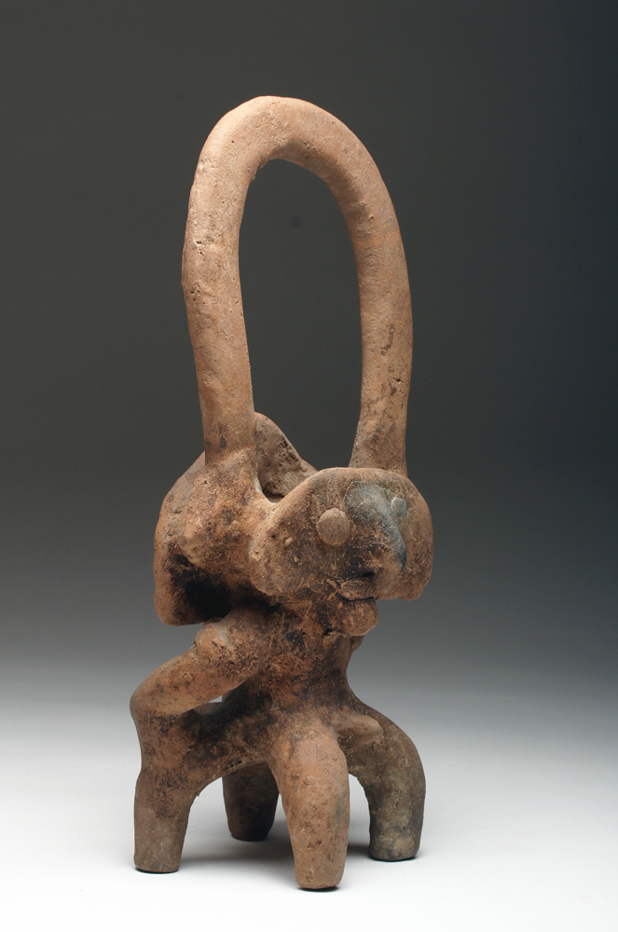

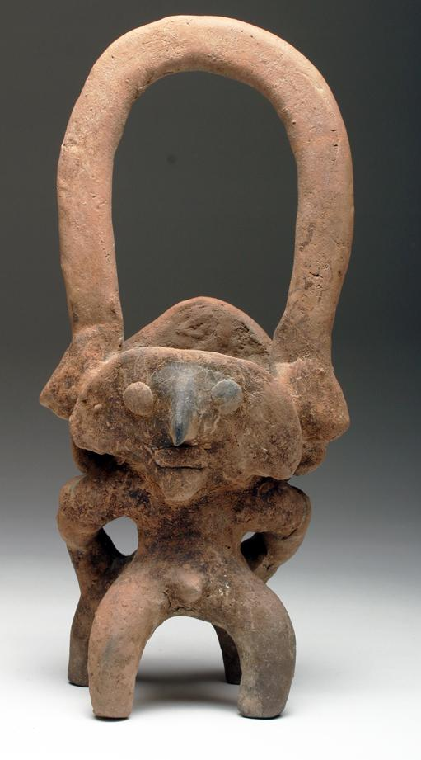 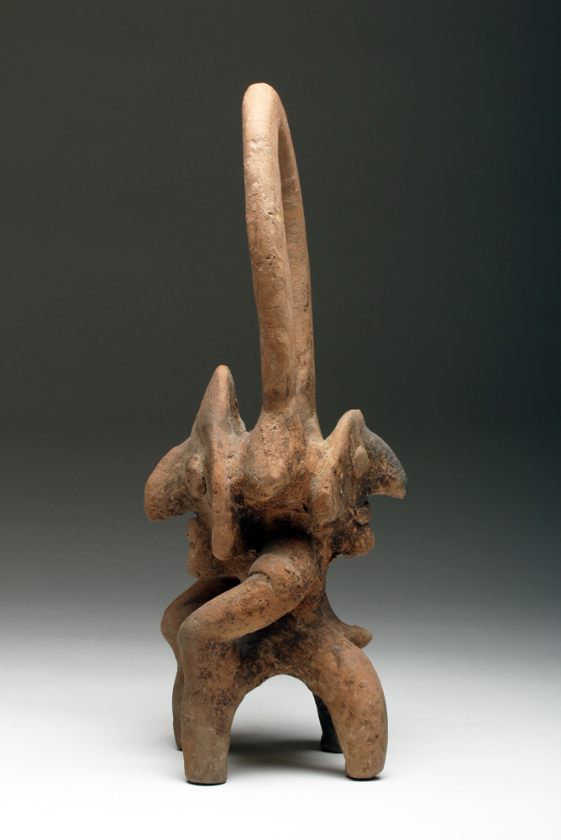 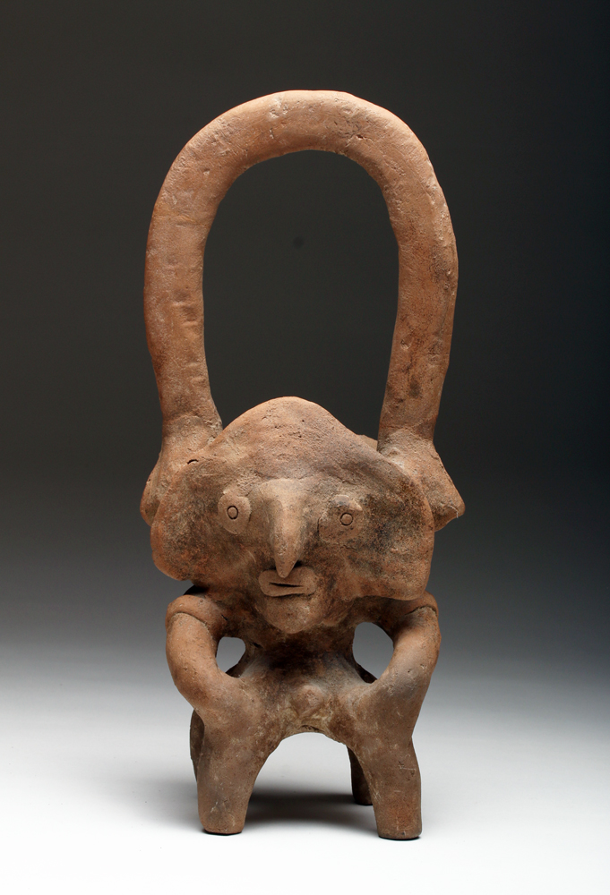 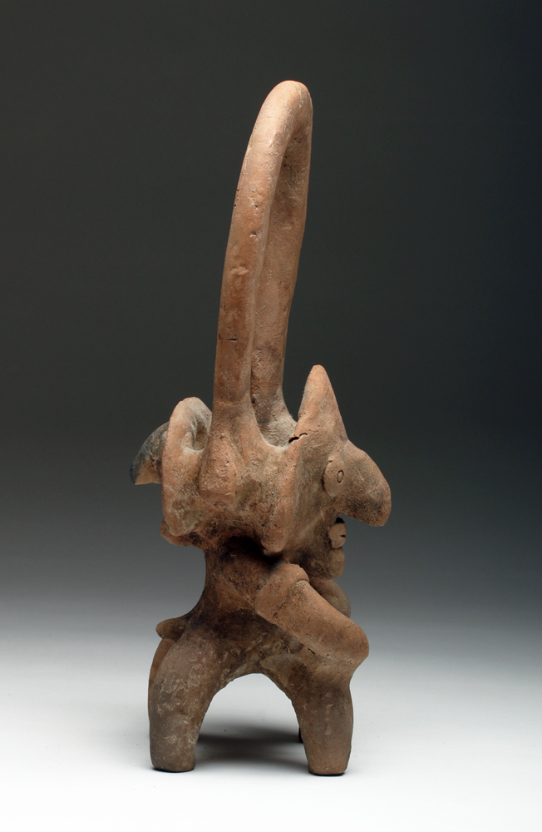

# Order details

## Sales order

Sold by [artemisgallery](http://myworld.ebay.com/artemisgallery) ( [637](http://feedback.ebay.com/ws/eBayISAPI.dll?ViewFeedback&userid=artemisgallery) )

### Delivery package 1 of 1

Estimated delivery Tuesday, Feb 2, 2016

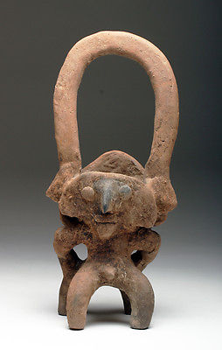

#### [Colima Incensario in Form of Tlaloc](http://www.ebay.com/itm/381258126822)

|  |  |
| --- | --- |
| Item price | $595.00 |
| Quantity | 1 |
| Item number | 381258126822 |
| Shipping service | UPS Ground |

## Shipping address

Ralph J Coffman Jr

149 Atlantic Ave

Swampscott MA 01907-2427

United States

## Order total

|  |  |
| --- | --- |
| Subtotal | $595.00 |
| Shipping | $44.99 |

**Total**

$639.99

Order placed on

Monday, Jan 25, 2016

Payment method

PayPal

Payment date